**VITAL ORGAN HEALTH PREDICTOR**

Submitted in partial fulfilments of the requirements

of the degree of

BACHELOR OF COMPUTER ENGINEERING

by

Rakshit Shah (19102008)

Catherene Joshi (19102007)

Poojan Shah (20202001)

Rutuja Jain (19102044)

Guide

Prof. Rushikesh Rajendra Nikam



Department of Computer Engineering

1. P. SHAH INSTITUTE OF TECHNOLOGY, THANE

University of Mumbai

2022-2023

A. P. SHAH INSTITUTE OF TECHNOLOGY, THANE

CERTIFICATE

This is to certify that the project entitled “**Vital Organ Health Predictor**” is a bonafide work of **Rakshit Shah** (19102008), **Catherene Joshi** (19102007), **Poojan Shah** (20202001), **Rutuja Jain** (19102044)” submitted to the University of Mumbai in partial fulfillment of the requirement for the award of the degree of Bachelor of Engineering in Computer Engineering.

**________________________________ __________________________________**

Guide Project Coordinator

Prof. Rushikesh R. Nikam Prof. Rushikesh R. Nikam

_______________________ ______________________

Head of Department Principal

Prof. Sachin H. Malave Dr. Uttam D. Kolekar

Date:

A. P. SHAH INSTITUTE OF TECHNOLOGY, THANE

**Project Report Approval for B.E.**

This project report for Sem-VIII entitled **“Vital Organ Health Predictor”**by **Rakshit Shah (19102008), Catherene Joshi (19102007), Poojan Shah (20202001), Rutuja Jain (19102044)** is approved for the degree of ***Bachelor of Engineering*** in ***Computer Engineering***, ***2022-23***.

Examiner Name Signature

1. ___________________________

2. ___________________________

Date:

Place:

**Declaration**

We declare that this written submission represents my ideas in my own words and where others' ideas or words have been included, I have adequately cited and referenced the original sources. I also declare that I have adhered to all principles of academic honesty and integrity and have not misrepresented or fabricated or falsified any idea/data/fact/source in my submission. I understand that any violation of the above will be the cause for disciplinary action by the Institute and can also invoke penal action from the sources which have thus not been properly cited or from whom proper permission has not been taken when needed.

-----------------------------------------

Rakshit Shah (19102008)

-----------------------------------------

Catherene Joshi (19102007)

-----------------------------------------

Poojan Shah (20202001)

-----------------------------------------

Rutuja Jain (19102044)

Date:

**Abstract**

Heart disease is a leading cause of death worldwide. The ability to predict heart disease using reports data, electrocardiograms (ECG), or audio of heartbeats is crucial in preventing heart-related ailments. In recent years, advancements in machine learning algorithms have enabled medical professionals to analyze patterns and changes in the data to diagnose heart disease at an early stage. Wearable devices can also be integrated to provide real-time updates to healthcare professionals. Predictive analytics can be used to identify specific risk factors for heart disease in different demographics, leading to targeted preventive measures. Personalized treatment plans can be developed for patients, ultimately leading to better outcomes. With the rampant increase in heart failures at juvenile ages, we need to put a system in place to be able to detect the symptoms of a heart stroke at an early stage and thus prevent it. At times, it is difficult for a common man to meet with the doctors and thus there needs to be a system in place which is handy and at the same time reliable, in predicting the chances of a heart disease. Thus, we propose to develop an application which can predict the vulnerability of a heart disease given basic symptoms like age, sex, chest pain, resting blood pressure, resting ECG, max heart rate, exercise angina, old peak and ST stope. There is always a need for a good predictor which will assist medical professionals in predicting the heart health of a person. Heart health can be predicted based on several reports, heartbeats and ECG or cardiogram images. Along with that Two other models that we propose will predict heart health based on Audio of heartbeat and ECG Image. The various machine learning algorithms used to predict results from audio or given input parameters have proven to be the most accurate and reliable algorithm and hence used in the proposed system.

**CONTENTS**

1. Introduction 1
2. Literature Survey 3
3. Limitation of Existing System 15
4. Problem Statement, Objectives and Scope 17

4.1 Problem Statement 17

4.2 Objectives 17

4.3 Scope 17

1. Proposed System 19

5.1 Proposed System Overview 19

5.2 Design details 20

5.3 Methodology 23

1. Experimental Setup 26
2. Results 28
3. Project Plan 35
4. Conclusion 36
5. Future Scope 37

References 39

Publications 41

**LIST OF FIGURES**

5.1 Architecture Diagram 19

5.2.1. Data Flow Diagram (level 0) 20

5.2.1. Data Flow Diagram (level 1) 20

5.2.3 Activity Diagram 21

5.2.4 Sequence Diagram 22

7.1 Home Page 29

7.2.1 Report Model-1 30

7.2.2 Report Model-2 31

7.3.1 Audio Model-1 32

7.3.2 Audio Model-2 32

7.4.1 Image Model-1 33

7.4.2 Image Model-2 34

**LIST OF TABLES**

2.1 Literature review Table 8

**Abbreviation**

|  |  |
| --- | --- |
| *ECG* | Electrocardiogram |
| *ML* | Machine Learning |
| *NB* | Naïve Bayes |
| *LR* | Logistic Regression |
| *RF*  *CNN*  *WHO* | Random Forest  Convolutional Neural Networks  World Health Organization |

*MFCC* Mel-frequency cepstral coefficients

**CHAPTER 1**

**Introduction**

The modern lifestyle has some bad things to do with the health of people. Sedentary lifestyle, no exercise, increased junk food intake, stress, tension, and a bad sleep schedule have definitely led to an increase in health issues. This new lifestyle has affected heart health a lot. Although the rate of heart diseases has increased in the past few years, heart diseases have always been a matter of concern.

Heart disease is a major health concern globally, and its prevalence is increasing at an alarming rate. According to the World Health Organization (WHO), cardiovascular diseases (CVDs) are responsible for nearly 17.9 million deaths every year, making it the leading cause of death worldwide. Heart disease is a broad term that encompasses various conditions that affect the heart, including coronary artery disease, heart failure, and arrhythmias. Early detection and prevention of heart disease are critical in reducing the burden of CVDs on individuals and society. Cardiovascular diseases i.e., heart diseases are the leading cause of death worldwide. According to the WHO, about 85% of all the deaths from heart disease are due to heart attack. If efficient diagnosis of cardiovascular disease is detected at an earlier stage, many lives can be saved. There is always a need for a good predictor which will assist medical professionals in predicting the heart health of a person.

Advancements in machine learning algorithms and technology have provided new opportunities for predicting heart disease. Researchers are exploring ways to use reports data, electrocardiograms (ECG), and audio of heartbeats to predict heart disease. Reports data, which includes clinical history, demographic data, and laboratory results, is a valuable source of information for predicting heart disease. Machine learning algorithms can analyse this data to identify patterns and trends that can be used to diagnose heart disease at an early stage.

ECG is a non-invasive test that measures the electrical activity of the heart. Abnormalities in the ECG signal can indicate heart disease. Machine learning algorithms can be trained to analyse ECG signals to identify patterns that indicate heart disease. Audio of heartbeats is also being explored as a potential source of information for predicting heart disease. Researchers are using deep learning algorithms to analyse the sound of heartbeats to diagnose heart disease.

Predicting heart disease based on reports data, ECG, or audio of heartbeats is a promising area of research. Advancements in ML algorithms, wearable devices, and technology are providing new opportunities for early detection and prevention of heart disease. The use of personalized treatment plans based on predictive analytics can further improve the outcomes for patients.

Predictive analytics is another area of research that is gaining attention in the field of heart disease prediction. By using predictive analytics, researchers can identify specific risk factors for heart disease in different demographics. This information can be used to develop targeted preventive measures for individuals and populations. The ability to personalize treatment plans for patients can also lead to better outcomes, as treatment plans can be tailored to the specific needs of each patient.

Heart health can be predicted based on several reports, heartbeats and ECG or cardiogram images.

It can enable healthcare professionals to diagnose heart disease at an early stage, reducing the risk of complications and death. Early detection of heart disease can also lead to the implementation of preventive measures, such as lifestyle changes and medication, which can help reduce the risk of heart disease.

While the potential benefits of heart disease prediction using reports data, ECG, or audio of heartbeats are significant, there are also challenges that need to be addressed. One of the main challenges is the availability of data. While reports data and ECG are readily available, audio of heartbeats requires specialized equipment, which may not be widely available. Another challenge is the interpretation of data. Machine learning algorithms can identify patterns and trends, but the interpretation of these results still requires the expertise of healthcare professionals.

Despite these challenges, the future of heart disease prediction is promising. With the continued advancement of machine learning algorithms and wearable devices, we can expect to see more accurate and efficient methods for predicting heart disease. Personalized treatment plans based on predictive analytics will further improve outcomes for patients. Overall, the potential benefits of heart disease prediction make it a critical area of research that requires continued attention and investment.

This project, Vital Organ Health Predictor aims at predicting the heart health of a patient based upon either report data, audio data of heartbeats or image data of cardiogram.

**CHAPTER 2**

**Literature Survey**

Heart disease, alternatively known as cardiovascular disease, encases various conditions that impact the heart and is the primary basis of death worldwide over the span of the past few decades. It associates many risk factors in heart disease and a need of the time to get accurate, reliable, and sensible approaches to make an early diagnosis to achieve prompt management of the disease. Machine Learning plays an important role in improving the quality of life. Early detection of diseases can help save lives. M. B. Abubaker et al [14] mentions the power of deep learning techniques used to predict cardiac abnormalities and normal person classes using the public ECG images dataset of cardiac patients. According to the experimental results, the performance metrics of the proposed CNN model outperform the exiting works; it achieves 98.23% accuracy, 98.22% recall, 98.31% precision, and 98.21% F1 score. Moreover, when the proposed CNN model is used for feature extraction, it achieves the best score of 99.79% using the NB algorithm.

K. Kumar et al [5], emphasized the fact that MFCC is the main approach for feature extraction. There are multiple features in sound signals which help in such analysis. There are many approaches such as wavelet analysis. In this paper there is a sound classification using the proper feature extraction followed by proper classification using a fast efficient neural network-based approach is proposed. This algorithm processes and classifies the sound input dataset and helps in high classification rate classification. The result obtained shows the high value of accuracy and less value of error rate. from the given proposed CNN solution. Thus, the approach is efficient and can be used further for better classification.

N. Jain et al [6], proposed a sequential model for audio features within a short interval of time. The model will use Mel Frequency Cepstral Coefficients to extract features from the audio files and present it in the model. The authors have chosen Librosa because Librosa makes all the files into the same sample rate (mono channel) and makes the data easy to work on audio processing. Sequential model provided the best accuracy at 70 percent when using the mean values of all features. Deep learning models enable audio signals processing and base on the patterns detected from the chirping of the birds, their species would be identified. Librosa, a python package, is used to process this audio data. These audio signals are visually represented, and the necessary features are extracted. This package contains the MFCC function which helps in describing the general shape of these spectrums. On applying the CNN model to these extracted feature attributes, the appropriate answer can be deduced.

F. S. Alotaibi [3] made use of the UCI heart disease dataset. The results and comparative study between Naive Bayes, Decision Tree, RF, SVM, Logistic regression showed that the current work improved the previous accuracy score in predicting heart disease. Decision Tree and Random Forest worked better with this dataset as compared to Naive Bayes and Logistic Regression.

S. Nandini et al [4] mentions how Decision Tree is one of the effective data mining methods till this date. But after comparing the following algorithms: Decision Tree, Naïve Byes, Support vector machine (SVM), k-nearest neighbors' algorithm (KNN), Logistic regression, Random Forests. Among the experiments carried out, the accuracy of the proposed system was 89% achieved with the Random Forest. The range of accuracy lies between 75%-89%.

In the published research paper, H. Purwins et al [21] shed light on the usage of “Deep Learning” in processing the audio and extracting the desired features. Usually, when audio is to be processed, MFCCs are mostly used. But in the case of sound recognition, log-mel spectrograms provide the ideal representation even in cases of models built on small datasets. When audio needs to be synthesized or enhanced, raw waveforms or complex spectrograms work better than log-mel spectrograms. Previously, “Support Vector Machines (SVM)” and “Gaussian Mixture Model (GMM), and Hidden Markovian Model (HMM) were used for sequence classification and sequence transduction respectively. These methods have now been replaced by Deep Learning models. CNNs, RNNs as well as CRNNs could be employed to solve most of the problems.

In the paper [11], M. Saw, T. Saxena, S. Kaithwas, R. Yadav, N. Lal have shown how their proposed system classifies whether a patient has a heart disease or not based on some parameters. Logistic regression of machine learning has been used in this work. The data set used in this paper is from an ongoing cardiovascular study on residents of the town of Framingham Massachusetts. To predict the 10-year risk of future coronary hard disease (CHD) is the goal of this proposed system. According to the author, hypertension has been the most important single identifiable risk factor for heart failure. Smoking damages the heart and blood vessels very fast but for most smokers who stop smoking the damage is quickly repaired. Greater blood vessel contraction is also caused by high blood sugar. When it comes to cardiovascular and heart disease, age is the most important factor. Around 82% of people who die from coronary heart disease are estimated to be of 65 years of age or older. Random search technique, where random combinations of the hyper parameters are used to find the best solution for the built model, is used in the proposed system. The data set used contained various features like age, gender, chest pain, slope, BMI, number of cigarettes per day, glucose levels, heart rate etc. Sklearn library was used to calculate scores. The result was analyzed with the help of comparing models and confusion matrix function was used in order to get the graphical representation of the classified data. The model was found to be highly specific than sensitive. As compared to women, men seemed to be more susceptible to heart disease. Increasing chances of having heart disease were also shown by increase in age number of cigarettes smoked per day and systolic blood pressure. No significant change was shown in odds of CHD by cholesterol level. The presence of good cholesterol can be a reason for this. The accuracy of this model was 0.87.

The authors, S. Babu, Vivek EM, Famina KP, Fida K, Aswathi P, Shanid M, Hena M, claim that the main advantages of this paper [12] are early detection of heart disease and its diagnosis correctly on time and providing treatment with affordable cost. The aim of this project was to diagnose the disease that early state. As the treatment for heart diseases is not affordable for everyone, people are reluctant to do proper treatment at early stages of disease. Authors say that by using data mining technique we can detect disease at an early stage and also completely cure the disease by proper diagnosis and treatment. Huge amount of data is collected by the Health Care industry, but which is not mined to discover hidden information. The remedy for this problem is data mining technique. It is the process of analyzing a large set of data and summarizing it into useful information. Data mining techniques are – association, classification, and clustering.

Association rule mining is a method for the discovery of interesting relations between variables in large databases. It intends to identify strong rules discovered in databases using some measurements that are used for generating Association rules. An Apriori algorithm and Mafia algorithm are used. Maximal frequent items set is generated using the Mafia algorithm before finding all frequent item set and once, we find maximal frequent item set we can generate all frequent item set in single scan.

Some databases containing huge amount of data classification model can be used to extract a model describing important classes. The classification techniques are decision tree algorithm and naive bayes algorithm. Decision tree takes care of various issues like missing value outlier and identifying significant dimensions whereas naïve bayes is supervise algorithm. It assumes an underline probabilistic model. It is an assumption. Decision tree is better than naïve bayes algorithm.

The process of grouping the same characteristic data into classes or clusters is known as clustering. K-means clustering algorithm is used for clustering. This algorithm is faster than other clustering algorithms and works great if clusters are spherical.

The proposed system is used for early diagnosis of heart disease, and it is carried out using data mining techniques. This research provides the prototype ‘Heart Disease Diagnosis Using Data Mining Techniques’ - genetic algorithm, K-means algorithm, Mafia algorithm and decision tree classification. A genetic algorithm is a search that imitates the process of natural evolution. In the proposed system a genetic algorithm is used to extract each attribute from a huge attribute set. The extracted attributes were age, sex, CP that is chest pain type, trestbps, cholesterol, fbs, restecg, thalach, exang, oldpeak, slope, ca, thal.

The focus of the authors in this paper was on using different algorithms in data mining and sequence of several attributes for effective heart disease prediction and its diagnosis. Decision tree had great efficiency, using 14 attributes, after applying genetic algorithm to reduce the actual data size to get the optimal subset of attribute acceptable for heart disease prediction.

There is a very high demand for early detection and prevention of stroke diseases to avoid the serious conditions of patients. The research work [13] focuses on two aspects - the first one is to identify the abnormalities in ECG data of stroke patients and the second one was the proposal of a deep learning model with the use of long short-term memory. It uses and electronic cardiogram (ECG), Electroencephalogram (EEG), blood pressure, pulse and pedometer reading to detect stroke related diseases.

The literature review discusses the prevalence of cardiovascular diseases and the importance of early detection using non-invasive tools such as ECG. The review [14] highlights the potential of machine learning and deep learning techniques in predicting heart diseases automatically. Various feature extraction and selection methods used in machine learning algorithms are explained. Several studies are cited that compare the performance of various machine learning algorithms in predicting heart diseases using datasets such as the UCI Cleveland heart disease dataset and the South African heart disease dataset. The review concludes that deep learning techniques and proposed CNN models outperform existing methods, achieving high accuracy, recall, precision, and F1 scores. The proposed CNN model also achieves the best results when used for feature extraction with the Naïve Bayes algorithm.

The data set used in this work was collected from various hospitals in India using real time environment. The data set is real data set and it consists of record for the past 5 years. It consists of 4068 records and those are classified into four groups based on disease types. Each group was divided into two sets - for training, 75% and for testing, 25%. Each group also had equal distribution of male and female patients because the ECG signals have a different scenario for males and females. Suitable for ECG segmentation, LSTM could recognize and retain short term and long-term dependencies between the data of an input time series for a long time. Parameters used in this research work are P wave, PR interval, QRS Complex, ST- segment, T wave and QT interval. Various parameters such as accuracy, sensitivity, precision and f1 score were used to evaluate the proposed model. The paper indicates that deep belief network models were better suitable for stroke related disease prediction mechanism. LSTM gave an accuracy of 93.78%. Thus, to employ LSTM model for ECG signal classification for early prediction of disease was the main contribution of this work.

Artificial Neural Networks (ANN) can solve complex problems. B. D. C. Ramesh et al [23] make use of various ANN algorithms to detect the Alarm sound. Among CNN, RNN, long short-term memory (LSTM), and generative adversarial network (GAN), CNN classifier predictions showed the highest accuracy. Fast Fourier Transform (FFT) is applied to the audio data and from this data now consisting of uniform, defined length, features are extracted. After calculating the MFCC, CNN model is applied onto it. The model is optimized using backpropagation algorithms and Adam Optimizer. This resulted in achieving a good accuracy score as well as computation speed.   
D. R. Megalmani et al [24] proposed two methods for “Unsegmented Heart Sound Classification”. Comparison was shown among the methods those with and without the feature extraction steps. It was noticed that the MFCC network had performed better than the Feature Extraction Network by a margin of 1.57 in terms of accuracy. But both methods have high sensitivity which is a crucial aspect for an application that has to correctly identify those patients that have CVDs.

Classification of the heart sounds form a crucial step in diagnosing the abnormalities in a patient. The differences between the peaks in the recordings signifies whether a patient's heart is healthy or not. In their study, W. Chen et al [16] has mentioned the steps and has provided a comparative study of various techniques that could be used to classify the cardiac sounds. The heart sound signals are first denoised using techniques such as wavelet denoising, empirical mode decomposition denoising, and digital filter denoising [17]. The audio data is then segmented to distinguish the different categories of the sound. The next important step comprises of using the MFCC as well as Mel domain filter coefficients (MFSCs), and heart sound spectra [18], and time and frequency features [19,20]. The authors had provided a comparison among the traditional Machine Learning methods as well as the Deep Learning methods such as 1D-CNN, 2D-CNN, RNN, etc along with MFSC, MFCC, etc as the input features. The strengths of the Deep Learning methods outweigh the limitations of the traditional methods.[25] The article discusses the use of data mining, artificial intelligence, machine learning, and deep learning techniques to obtain relationships or identify significant databases in the field of medical data mining and knowledge exploration. Specifically, the article focuses on the prediction of heart disease using feature selection algorithms, which include filter-based, wrapper-based, and embedded techniques. The study performs experiments on real datasets available through the University of California, Irvine data repository and evaluates the performance of various feature selection algorithms against six classification algorithms. The primary objective of the article is to examine the effect of feature selection approaches on the accuracy of heart disease prediction, with the goal of benefiting the medical community.[22] The paper proposes a new technique for the effective recognition of arrhythmias based on ECG signal using the AAMI standard. The proposed methodology consists of three crucial stages: pre-processing, feature extraction, and classification. In the pre-processing step, noise is removed from the recorded ECG signal. Temporal and frequency domain features are extracted from the pre-processed ECG signal using dual-tree complex wavelet transform (DTCWT) in the feature extraction stage. The extracted feature set is appended and applied as an input to the random forest classifier for automatic recognition of cardiac arrhythmia beats in the last stage of the proposed methodology. The proposed work can classify arrhythmias with an overall accuracy of 99.52%. The proposed approach can be utilized in automatic ECG signal analysis, patient monitoring systems, and arrhythmia detection systems.

|  |  |  |  |
| --- | --- | --- | --- |
|  | **Paper Name** | **Strengths** | **Drawbacks** |
| [1] | “Heart Disease Prediction using Machine Learning Techniques” (2020) | RF performed best (99% accuracy), followed by SVM(98% accuracy) | Decision tree has the least accuracy of 85% as compared to other models.  SVM and Random Forest model give out the prediction value almost the same.  The Decision Tree was not suitable for the dataset provided. |
| [2] | “Heart Disease Prediction Using Machine Learning”, (2022) | Concluded that the SVM model performed the best. | RF, NB model does not work accurately for this dataset. |
| [3] | “Implementation of Machine Learning Model to Predict Heart Failure Disease”, (2019) | Provided a detailed comparative study between Naive Bayes, Decision Tree, RF, SVM, Logistic regression. | Naive Bayes and Logistic Regression does not work well for this dataset. |
| [4] | “Heart Disease Prediction using Machine Learning”,(2018) | Experiments were carried out with some popular algorithms like KNN, Decision Tree, Random Forest, Naive Bayes, SVM, Logistic Regression. The holdout test and the accuracy of the proposed system was 89% achieved with the Random Forest. | The range of accuracy lies between 75%-89%. The accuracy of Decision Tree is the lowest for this dataset. |
| [5] | “An Audio Classification Approach using Feature extraction neural network classification Approach” (2020) | It concluded that the CNN model performed the best. There are many approaches such as wavelet analysis, chroma, centroid based approach and MFCC is the main approach for such feature extraction. | The scope of accuracy could be improved by increasing the number of classes and adding more unique features to each class. |
| [6] | “Implementation of Bird Species Detection Algorithm using Deep Learning” (2022) | In this paper, a comparison is done between the 2 libraries in Python that are used to work on audio files- Librosa and Scipy. Librosa is the better alternative because Librosa makes all the files into same sample rate (mono channel) and makes the data easy to work on audio processing | Applying the Sequential model, their dataset gave an accuracy of 70% which can be optimized. |
| [7] | “Predicting Heart Disease at Early Stages using Machine Learning: A Survey” | A Summary on the performance of different Supervised Machine Learning Algorithms used for heart disease prediction are ANN, DT, RF, SVM, NB and KNN algorithm. | Need for an automated system to predict heart disease at earlier stages.  It is better to use search algorithms for selecting the features and then applying machine learning techniques for prediction will give us better results in the prediction of heart disease. |
| [8] | “A Classification Approach for Heart Disease Diagnosis using Machine Learning” | Used four different Machine Learning classification techniques - Support Vector Classifier, Logistic regression, NB, DT. | Decision tree and Support Vector Classifier techniques are less accurate as compared to other techniques. Naive Bayes takes more processing time as compared to other techniques. |
| [9] | “Feature Optimization Based Heart Disease Prediction using Machine Learning” | 3-fold cross validation is applied on the Algorithms to avoid bias performance. Highest average accuracy of 96% is achieved by the naïve Base | The accuracy achieved is satisfactory, but the real time heart disease prediction system should be more efficient. |
| [10] | “Cognitive Approach for Heart Disease Prediction using Machine Learning” | Five algorithms are used for heart disease prediction - Random Forest, Naïve Bayes, Support Vector Machine, Decision Tree, and Logistic Model Tree (LMT). Random forest gives maximum accuracy. | More input attributes must be used with the existing models and the analysis of the results must be performed. |
| [11] | “Estimation of Prediction for Getting Heart Disease Using Logistic Regression Model of Machine Learning” | Logistic Regression was used and the model predicted with an accuracy of 0.87. | The model could have been improved with more data and by using different Machine Learning models. Model was more specific than sensitive. |
| [12] | “Heart Disease Diagnosis Using Data Mining Technique” | Genetic algorithm, K-means algorithm, MAFIA algorithm and DT Classification were used. Decision Tree had the most accuracy. | To get an optimal subset of attributes for Decision Tree Classification, Genetic algorithm was used to reduce actual data size. |
| [13] | “Stroke Disease Prediction based on ECG signals using Deep Learning Techniques” | Dataset collected had real time values from different hospitals in India. LSTM gave an accuracy of 93.78%. | Models should be compared with other prediction models to get the best one. |
| [14] | “Detection of Cardiovascular Diseases in ECG Images using Machine Learning and Deep Learning Methods” | The proposed CNN model achieves good results. The CNN model gave an accuracy of 98.23%. | Models could achieve better results if optimization algorithms are used to determine the values of its hyper parameters. |
| [15] | “Deep Learning for Audio Signal Processing” | The dominant feature representations (in particular, log-mel spectra and raw waveform) and deep learning models are reviewed, including CNN, variants of the LSTM architecture, as well as more audio-specific neural network models. Subsequently prominent deep learning application areas are covered. | Applications with strict limits on computational resources, such as mobile phones or hearing instruments, require smaller models. |
| [16] | “CNN and Sound Processing-Based Audio Classifier for Alarm Sound Detection” | Based on supervised learning, the research has developed the novel CNN architecture for beep sound recognition in noisy situations. The proposed method gives better results with an accuracy of 96%. | Classifiers like SVM, KNN, random forest, produced relatively less accuracy and requiring more time in real-time predictions compared to CNN. |
| [17] | “Unsegmented Heart Sound Classification Using Hybrid CNN-LSTM Neural Networks” | Comparison was shown among the methods those with and without the feature extraction steps. It was noticed that the MFCC network had performed better than the Feature Extraction Network by a margin of 1.57 in terms of accuracy. | The baseline model didn’t perform as good as MFCC network did. |
| [18] | “Deep Learning Methods for Heart Sounds Classification: A Systematic Review” | Analysis of existing deep learning methods were performed in the present study, with an emphasis on the convolutional neural network (CNN) and recurrent neural network (RNN) methods developed. | The major problems requiring solutions include data insufficiency, training inefficiency, and insufficiently powerful models. |

Table 2.1: Literature Survey Table

**CHAPTER 3**

**Limitation of Existing system**

**3.1 Report Data Model**

Textual data, which includes clinical history, demographic data, and laboratory results, is a valuable source of information for predicting heart disease. However, there are several challenges that need to be addressed when using textual data for heart disease prediction.

The first model used in the prediction of heart health is based on the report data of the heart taking in parameters like age, chest pain type, resting bps, cholesterol, fasting blood sugar, resting ecg, max heart rate, exercise angina, old peak and ST slope.

One of the main challenges is the quality of the data. Textual data can be incomplete or inconsistent, making it difficult to extract meaningful information. Data cleaning and normalization techniques can be used to address this issue, but it can be time-consuming and labor-intensive.

Another limitation of this model is that it won’t be trained for any other parameter apart from these mentioned parameters and may not accept any other value apart from that range.

Finally, there are challenges associated with data privacy and security. Textual data often contains sensitive information, such as personal health information, which needs to be protected. Data anonymization techniques can be used to address this issue, but there is still a risk of re-identification.

**3.2 Heartbeat based audio model**

Audio data, which includes recordings of heartbeats, is another valuable source of information for predicting heart disease. However, there are several challenges that need to be addressed when using audio data for heart disease prediction.

The second model used for the prediction of heart health is based on Heartbeat audio, where the input is given for heartbeat’s audio and output is generated based on heart beats and method of those beats.

One of the main challenges is the quality of the data. Audio data can be noisy or distorted, making it difficult to extract meaningful information. Signal processing techniques can be used to address this issue, but it can be time-consuming and may require specialized expertise.

Also, it cannot yet differentiate between Human’s heart and Animal’s heart and can take input for the same and predict output.

Another challenge is the variability in heartbeats. Heartbeats can vary in rhythm, amplitude, and duration, making it difficult to identify patterns and trends. Machine learning algorithms can be trained to analyze audio data, but the development and implementation of these algorithms can be complex and require significant resources.

**3.3 Heart ECG based Image model**

The third model used for the prediction of heart health is based on the ECG Image of the Heart, where the input is given as Image file and output is generated based on the signals displayed in the Image and preprocessing of the Image done.

One of the main challenges is the variability in ECG image quality. ECG images can be affected by factors such as electrode placement, patient movement, and noise. Poor image quality can lead to errors in diagnosis and treatment. Signal processing techniques can be used to address this issue, but it can be time-consuming and may require specialized expertise.

Another challenge is the interpretation of ECG image data. ECG images can be complex and require expert interpretation. Machine learning algorithms can be trained to analyze ECG images, but the interpretation of the results still requires the expertise of healthcare professionals.

Also, it cannot differentiate between Human’s heart ECG and Animal’s heart ECG and can take any image input and predict the result.

**CHAPTER 4**

**Problem Statement, Objectives and Scope**

**4.1 Problem Statement**

To create a model that will Predict Heart health based on Reports, Heartbeat Audio and Cardiogram Images.

**4.2 Objectives**

* To aid the doctors in the diagnosis of a patient’s illness
* To predict the Health of Heart based on either Report data, Audio data or Image data of cardiogram.
* To avoid the patient's expense of reaching out to multiple doctors for a second opinion.

**4.3 Scope**

The main idea behind the project is that the Vital Organ Health Predictor could help the doctor to analyze the heart health of the patient. The scope of the heart disease prediction project is extensive, and it involves the application of machine learning techniques to different types of data such as reports, ECG, and audio data. The project aims to develop a comprehensive system that can accurately predict the risk of heart disease in patients based on various factors.

The first step of the project is to collect and preprocess the data. This includes collecting clinical data such as patient history, demographic data, and laboratory results. Additionally, ECG images and audio recordings of heartbeats will be collected and processed. The data will be cleaned and normalized, and appropriate feature extraction techniques will be applied.

Once the data is preprocessed, machine learning algorithms will be trained on the data to predict the risk of heart disease in patients. Different machine learning models will be evaluated to determine which models provide the highest accuracy. The models will be trained using a variety of machine learning algorithms.

All the data of a new patient will be recorded and based on that heart health will be determined. A patient will not have a need to visit multiple doctors for a second opinion. At some places, doctors are not available. In such situations, this application will play an important role. Also, sometimes, one needs to take a second opinion from another doctor or maybe the doctor herself may find a need to seek help from another doctor. In such cases too, this application will prove to be useful. The Vital Organ Health Predictor will also help in saving the time of both – doctor and patient and to build an intensive domain-specific application.

The project will also explore the use of natural language processing (NLP) techniques to analyze textual data such as clinical notes. NLP can be used to extract structured data from unstructured text, which can improve the accuracy of heart disease prediction.

The project will also investigate the use of wearable devices to collect data such as heart rate, activity levels, and sleep patterns. The use of wearable devices can provide additional data to improve the accuracy of heart disease prediction.

This work can be enhanced by applying more extensive data analysis and trying additional algorithms to reach the maximum possible accuracy. The outcome of the project will be a comprehensive heart disease prediction system that can accurately predict the risk of heart disease in patients. The system can be used by healthcare professionals to aid in diagnosis and treatment and can potentially lead to better health outcomes for patients. Additionally, the project can contribute to the development of new machine learning techniques for heart disease prediction and data analysis. Additional modules could be added to cover up other diseases related to the liver, lungs, brain, kidneys, skin, various types of cancers, etc. In future, the project will also investigate the use of wearable devices to collect data such as heart rate, activity levels, and sleep patterns. The use of wearable devices can provide additional data to improve the accuracy of heart disease prediction.

**CHAPTER 5**

**Proposed System**

**5.1 Proposed System Overview**

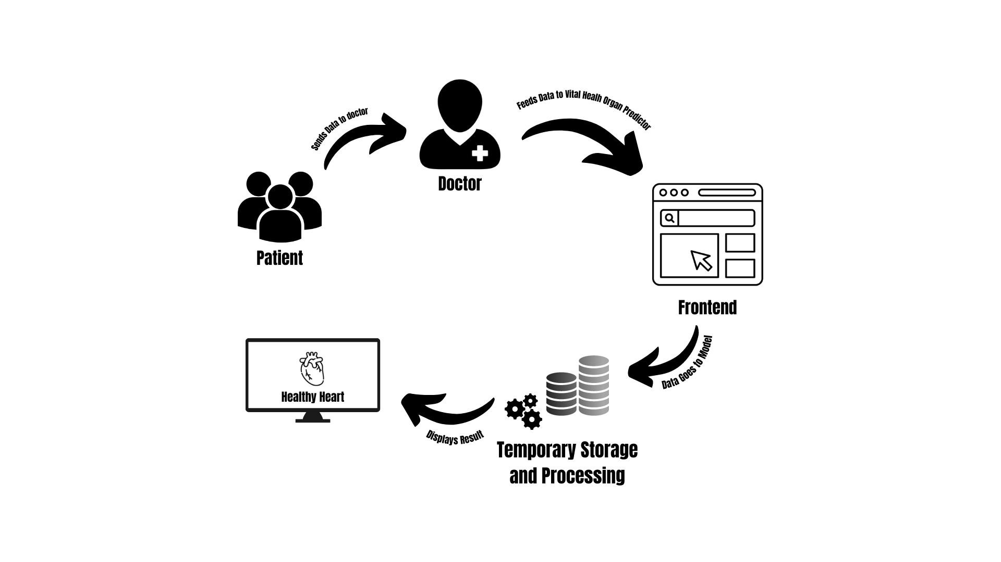

Fig 5.1: Architecture Diagram

Architecture diagram comprises the mapping of the physical components of the application system. In our project, the user could access the UI portal of the web application in which the input files would be stored and processed temporarily to generate the results.

**5.2 Design Details**

**5.2.1 DFD Diagram**

DFD or Data Flow Diagram shows the flow of information in a system.

**i. DFD Level 0**

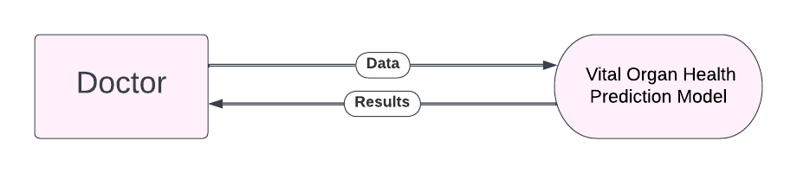

Fig 5.2.1: Data Flow Diagram Level 0

DFD Level 0 or Context Diagram shows the flow of information in the system as a single high-level entity. The user inputs the data to the application and the required results would be displayed to the user.

**ii. DFD Level 1**

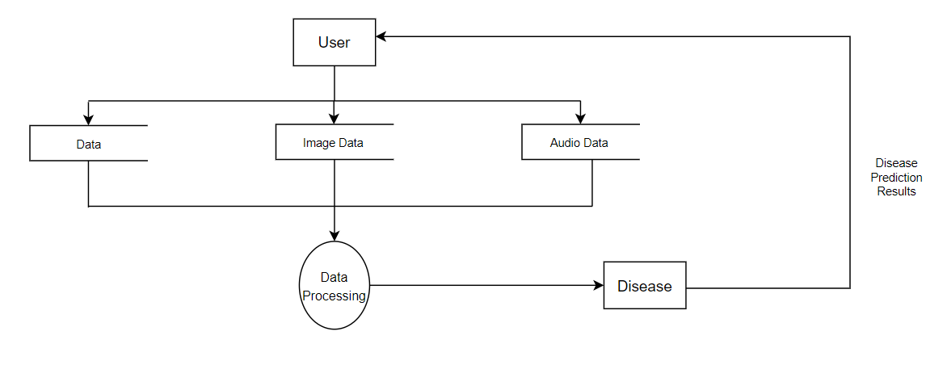

Fig 5.2.1: Data Flow Diagram Level 1

In DFD Level 1, the Context Diagram is decomposed into multiple detailed processes. The data such as audio data, image and the data from the report, is processed with the help of various algorithms. Using this processed data, the model predicts and outputs the results.

**5.2.2 Activity Diagram**

### Fig 5.2.2: Activity Diagram

### Activity Diagram shows the stepwise activities or processes in a graphical form. After landing on the home page, the user is given an option to upload data either in the form of audio, image and report and can input the data in their given respective fields. In either case, this data is sent to the model to give out the results.

**5.2.3 Sequence Diagram**

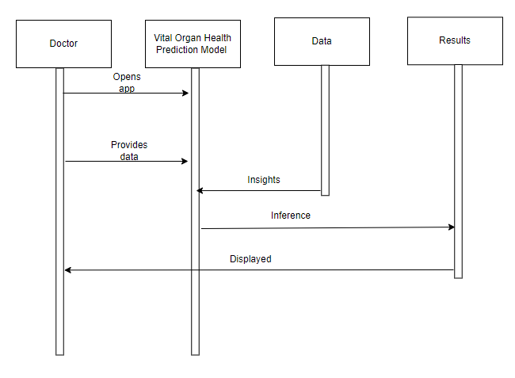

### Fig 5.2.3: Sequence Diagram

Sequence Diagram shows the interactions between entities in a sequential manner. In our system, the user first opens the web application. Input fields would be provided to upload or input the data. The user manually provides data. The application then seeks insights from the data that has been provided. The application then displays the results to the users.

### 5.3 Methodology

### 5.3.1 Data Model

### After going through the research papers, we concluded that the Random Forest algorithm would be suitable for our dataset and is the suitable choice as the algorithm generates pretty accurate and efficient results. Random forest is a part of Supervised Machine Learning Algorithm which is used widely to solve Classification and Regression problems. What this algorithm does is basically, it builds decision trees on different samples and takes their majority vote in case of classification and average in case of regression. One of the most important features of the Random Forest Algorithm is that it can handle the data set containing both continuous variables as in the case of regression as well as the categorical variables as in the case of classification. However, it performs better results for classification problems.

Using Pandas, we manipulated the data and performed analysis. Using sklearn, the dataset was split into training and testing data. sklearn makes use of the Random Forest Classifier to perform the Random Forest Classification. Using the heatmap from the Seaborn package, we visualized the heatmap with the correlation metrics to check if any features are highly related. These are removed to create a better Machine Learning Model. In our model, 80% of the data formed the training data set whereas 20% of the data formed the testing dataset. Now, we store the imported Random Forest Classifier into a variable named model. The Random Forest Classifier makes use of certain hyperparameters such as N-estimators that specify the number of trees that are to be built before taking the majority voting. In our case, the value 200 gave the optimal results as well as max_ depth which specifies the maximum depth of the decision tree model. Onto this, model fitting is applied. Now, we perform predictions using model.predict(). Our model has shown 0.93 as the average precision, recall, and f1-score values.

**5.3.2 Audio Model**

After going through all the research papers, the implementation of the audio model was made based on CNN and the Librosa library of Python for audio pre-processing. Various other libraries supporting librosa and CNN were imported namely scikit learn for model selection, metrics, preprocessing, train test split, classification report, accuracy score, label encoder etc. To import CNN model keras library was used as tensor flow is now inbuilt in keras.

The initial preprocessing included the audio file to be added in the data set with setting the initial of set and creating the audio data of 3 seconds only. Once the audio file was trimmed it was then appended into the data set for further processing. Further the audio file was preprocessed for its feature extraction where the Mel spectrogram of the audio file was calculated using librosa.feature and later the Mel spectrogram was converted to the power of decibel before it could get split for training and testing.

Further the data set was played into training and testing arrays and a label encoder was introduced to assign weights to the training and testing classes file. This weight class gives numeric values to the audio feature that was extracted in the previous step.

### The penultimate step includes the introduction of a model where we use a sequential model and add a convolution 2D layer with filter, kernel size, and input shape for the first layer. We even added the max pooling 2D layer which down samples the input along its special dimensions by taking the maximum value over an input window for each channel of the input. For convolution layers are added and one dense layer is added in the model creation. This type is followed by compiling the model by using the Adam optimizer and passing the training data set to the model with batch size, epochs, validation data, class weight, and shuffle. The final step now includes predicting the testing data using the created model where we upload a random audio file and append it into an array and pass through the extract feature and finally use the model.prit function and print the predicted value. The final output is printed as normal heartbeat or abnormal heartbeat with the confidence in numeric value as well. This Concludes the functioning of audio-based heart health detection model.

**5.3.3 ECG Image Model**

### After going through the literature review and understanding the difficulty of making a model that can predict based on image features, we decided to go ahead with Random Forest to build this model. In this, the ECG images as either "normal" or "abnormal" and to preprocess this data, various libraries, including OpenCV, NumPy, Matplotlib, and Keras are imported and are used to load and preprocess images, extract features, and train and evaluate a random forest model for classification.

### The program starts by displaying an ECG image and then applying various image processing techniques such as image enhancement, segmentation, resampling, and denoising to extract the ECG waveform from the image. It then resamples the waveform to a 1D signal and plots it. This is done by the extract_feature_ecg() function which takes an image path as input and returns a resampled ECG signal as a NumPy array. The function performs various image processing operations to extract the ECG signal from the input image. The image is then resized to a target size of (256, 256) pixels using the OpenCV ‘resize’ function. The image is enhanced using the OpenCV ‘MedianBlur’ and ‘normalize’ functions. ‘MedianBlur’ performs median filtering to remove noise from the image, while ‘normalize’ scales the pixel values to the range of 0 to 256. This step is followed by Segmentation and the image is converted to grayscale using the ‘cvtColor’ function. A binary thresholding operation is then performed using the ‘threshold’ function to segment the image into foreground (ECG waveform) and background regions. ‘FindContours' function extracts the contours of the segmented regions. Finally, the contour with the largest area is selected as the region of interest (ROI) that contains the ECG waveform. The next step is resampling of the ECG waveform to a 1D signal. This is done by first using OpenCV's ‘polylines’ function to draw the ‘ROI’ contour onto the grayscale image as a white line. The resulting image is then averaged across the rows to obtain a 1D signal. This signal is then converted to a float32 data type, and the x-axis values are generated using NumPy's ‘arange’ function. The final step is denoising the ECG signal using a moving average filter. This is done by convolving the signal with a ones filter of size 5 using NumPy's convolve function with mode='same'. This filtered signal is then plotted using Matplotlib's plot function, and the resulting plot object is stored in a variable named z. The x and y data points of the plot object are retrieved using the get_xdata and get_ydata methods, respectively, and stored in xdata and ydata. These data points are then combined into a 2D array using the np.array function and the transpose operation T. The resulting array z_array represents the denoised ECG signal, with the x coordinates in the first column and the corresponding y coordinates in the second column. Finally, the z_array is returned from the function as the extracted features for the input ECG image.

### The program then loads a dataset of ECG images from two folders, "Abnormal person ECG Images" and "Normal Person ECG Images (859)" and creates a pandas data frame to store information about the images such as the filename and the label. The notebook then plots a bar graph of the dataset distribution, which shows that the dataset is imbalanced with more "normal" images than "abnormal" images.

### The program then defines a function to extract features from an ECG image, which includes the same preprocessing steps as before. It then splits the dataset into training and validation sets, encodes the labels as integers, and applies class weights to balance the dataset. The notebook then builds a random forest model using the extracted features and trains it on the training set. Finally, it evaluates the model on the validation set using classification report, accuracy score, and confusion matrix.

**CHAPTER 6**

**Experimental Setup**

### 6.1 Requirement Analysis and details about input to systems or selected data.

Operating Systems such as Windows, Linux or MAC can be used, A minimum of 4 to 8 GB RAM is required to process the heavy models. At least 2.8Ghz CPU speed would be required. Visual Studio Code is a code editor redefined and optimized for building and debugging modern web and cloud applications. For running a project in data science or data visualization, one could use Jupyter notebooks inside VS Code. Python is an interpreted, high-level, and general-purpose programming language. The entire GUI and processing in this project will be done in python. In this project, we are going to use python's web-based framework, Flask. Flask's primary goal is to ease the creation of complex websites. CSS is used to style an HTML document. CSS describes how HTML elements should be displayed. Bootstrap is a framework which is used to create user interfaces in web applications. It provides css, js and other tools that help to create the required interfaces. In Flask, we can use bootstrap to create more user-friendly applications. Pickle file is used to save a machine learning model. Basically, it's the process of converting a Python object into a byte stream to store it in a file/database, maintain program state across sessions, or transport data over the network.

After processing the user input data through the Pickle file an output is displayed on the webpage through Jinja template.

Templates are enabled using the Jinja2 template engine and allow data to be shared and processed before being turned into content and sent back to the client.

### 6.2 Performance Evaluation Parameters (for Validation)

There are different Machine Learning Modules used in the project for the predictive analysis. Different parameters are considered by the machine learning models to give out an accurate prediction.

Different user input(reports) which are required for predicting the heart’s health are:

* Age
* Sex
* Chest Pain
* Resting Blood pressure
* Cholestrol
* Fasting Blood sugar
* Resting ECG
* Max Heart Reate
* Exercise Angina
* Oldpeak
* ST slope

### 6.3 Software and Hardware Set up

### i. Hardware requirements

* Operating Systems
* High Speed RAM
* Fast Processor

### ii. Software requirements

* VSCode
* Python 3.8 and above.
* HTML, CSS, JavaScript, Bootstrap

**CHAPTER 7**

**Result**

The UI of this application is designed in such a way that it gives ease of use to any user. When one opens the application, he or she has access to three different tabs for the three different types of data that the user can input in order to get the prediction of the heart health. On scrolling, one can see statistics of heart health which gives some information about heart health of people all over the world. One can click on the Know More button and learn more about how to keep the heart healthy. The button directs you to an article about heart health. The home page has cards for all the three modes i.e., Report Model, Audio Model, and Image Model. A short description for each of the models is also displayed. Each of the cards has one explore button. One clicking on the explore button, one will be able to access that model. Thus, on selecting the Report model, the person has to input all the parameters from the heart checkup report. On pressing the submit button, the application will tell whether the heart health of that person is good or not. When one selects the Audio model, he or she must upload an audio file of the heartbeats and the application will tell, based on the heartbeat audio, whether the heart is healthy or not. Lastly, when one selects the Image model, an image of ECG needs to be uploaded on the website and the application will predict whether the heart is healthy or not.

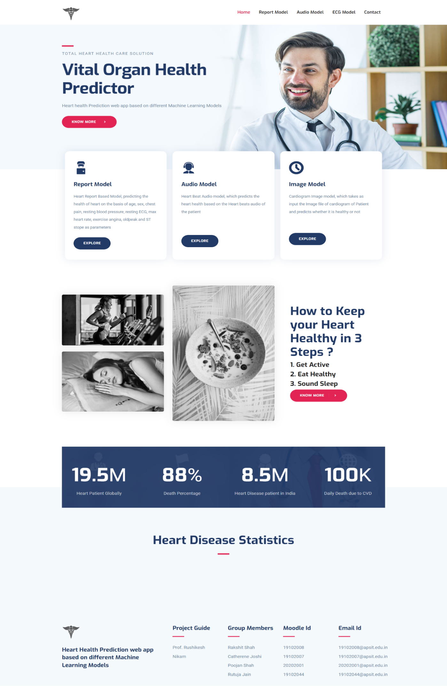

Fig 7.1: Home Page

**7.1 Report Model**

The UI of the textual data model is designed to provide an intuitive and user-friendly interface for healthcare professionals to interact with the system. The user would be able to enter the values given in the field. On submitting the data, the results will be displayed in a clear & concise manner.

The user gets to input the parameters in their respective fields. On pressing the Submit button, either ‘Healthy heart’ or ‘Not healthy heart’ would be displayed based on the result predicted by the model.

The goal is to provide healthcare professionals with a powerful tool that is easy to use and helps them make informed decisions about patient care.

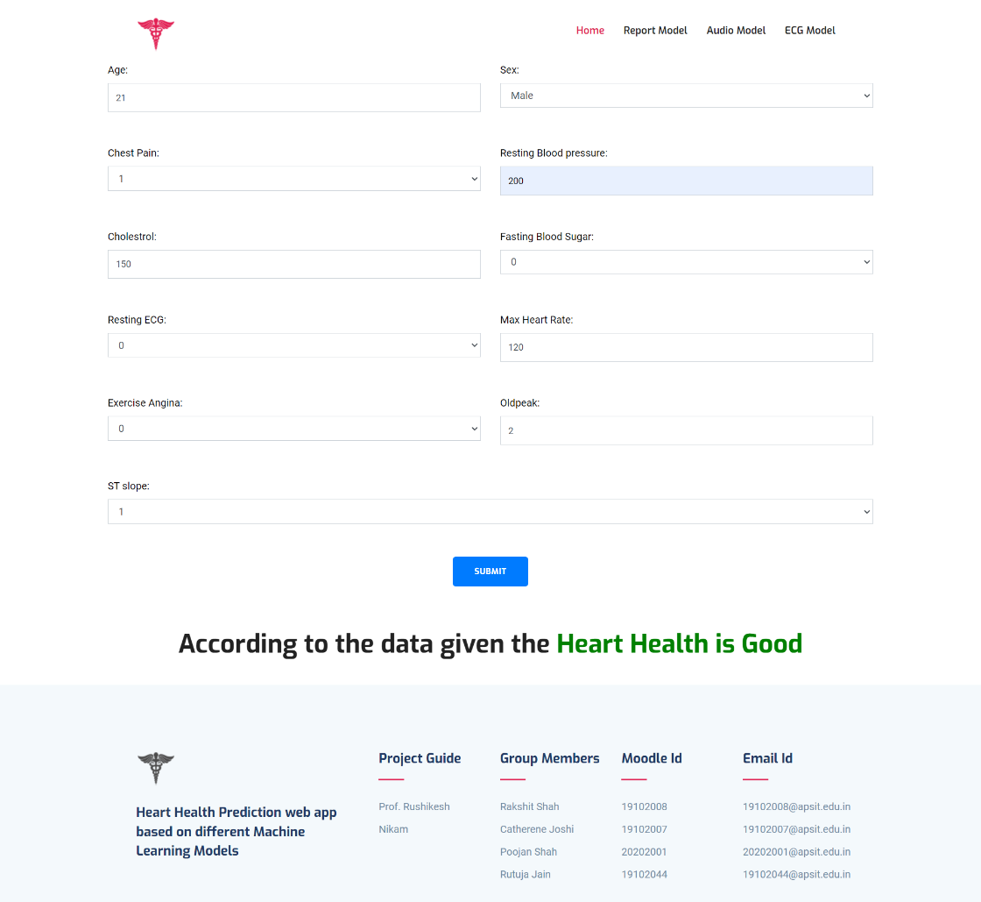

Fig 7.2.1: Report Model-1

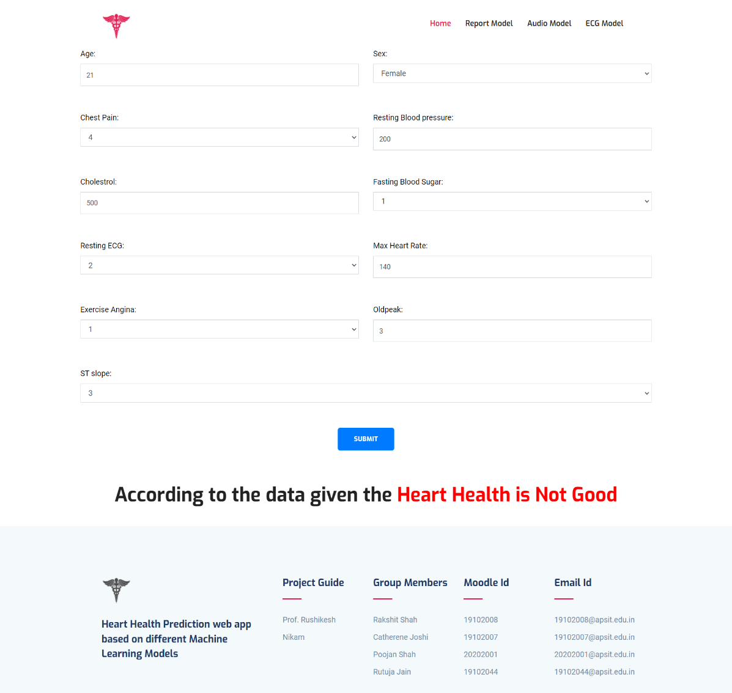

Fig 7.2.2: Report Model-2

**7.2 Audio Model**

The audio data model provides a user-friendly interface for healthcare professionals to interact with the system. The user would be able to choose and upload an audio file of heartbeats on the UI. On submitting the data, the results will be displayed in a clear & concise manner.

The user gets to input the parameters in their respective fields. On pressing the Submit button, either ‘Normal’ or ‘Abnormal’ would be displayed based on the result predicted by the model.

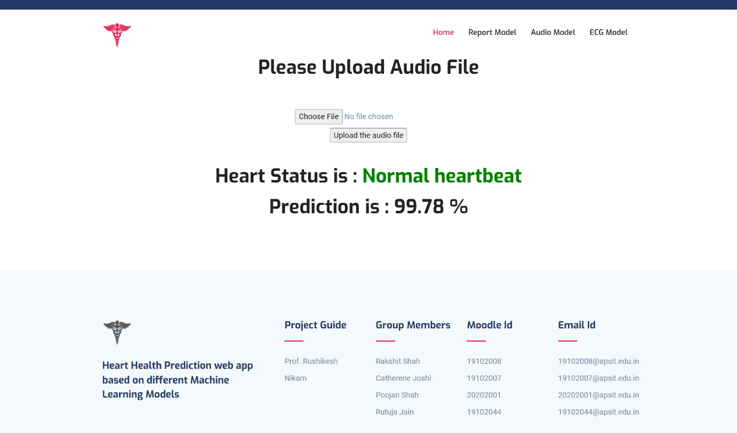

### Fig 7.3.1: Audio Model-1

### 

### Fig 7.3.2: Audio Model-2

**7.3 Image Model**

The image data model is designed to provide a user-friendly interface for healthcare professionals to interact with the system. The user would be able to choose and upload an ECG image file on the UI. On submitting the data, the results will be displayed in a clear & concise manner.

The user gets to input the parameters in their respective fields. On pressing the Submit button, either ‘Normal’ or ‘Abnormal’ would be displayed based on the result predicted by the model.

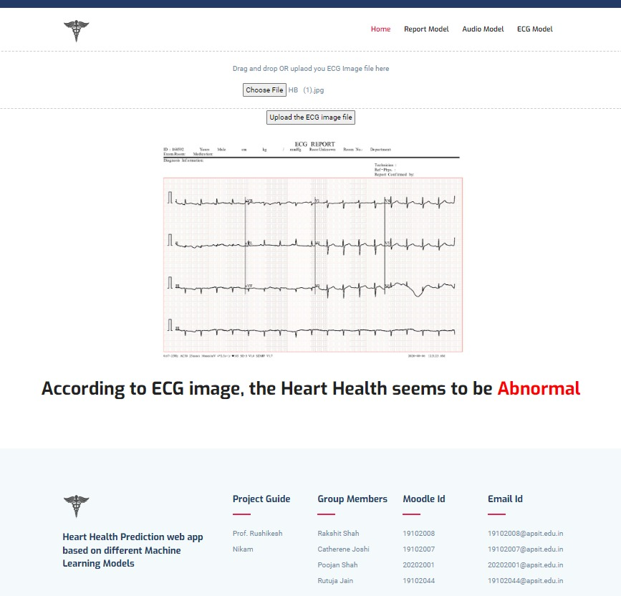

### Fig 7.4.1: Image Model-1

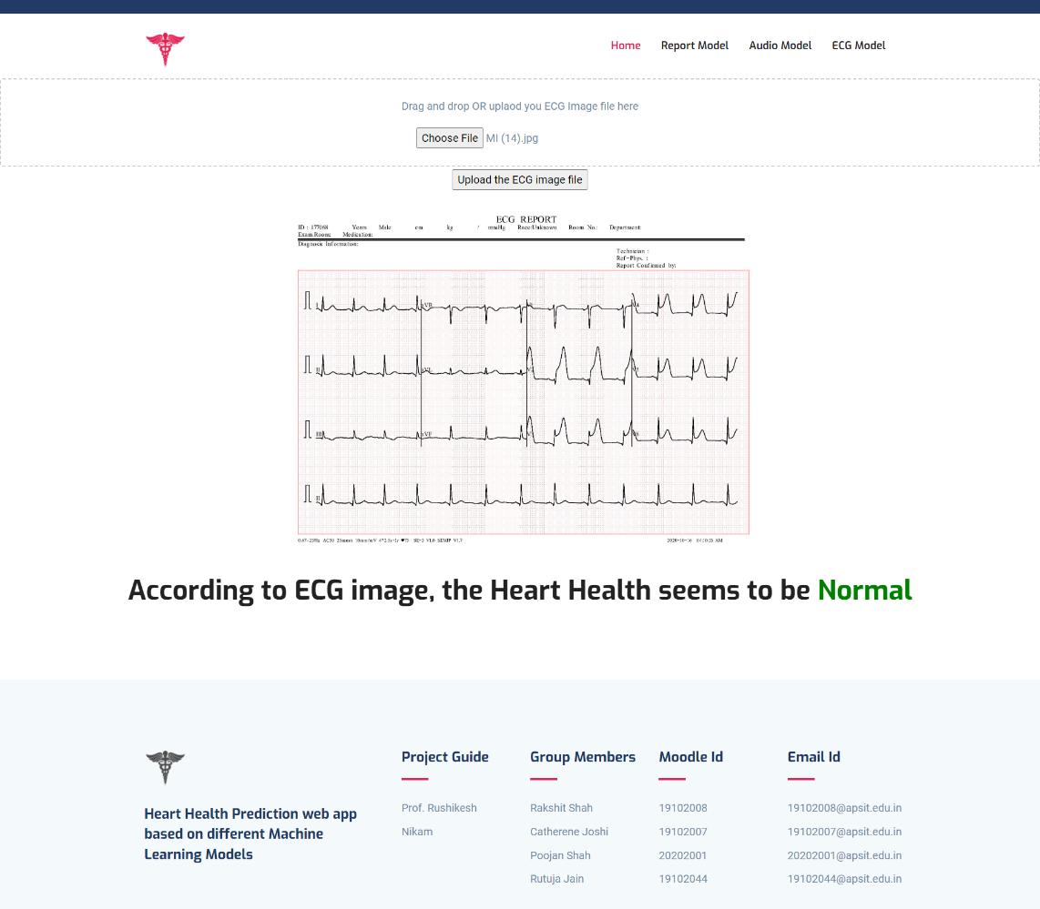

### Fig 7.3.2: Image Model-2

**CHAPTER 8**

**Project Plan**

Our project started in July 2022, and after finalizing the topic and objectives, we began working on it. Phase one covered project conception, project study, and design layout. In phase two, we designed our proposed system, and in the final third phase, we completed project implementation, and submitted a research paper along with our results.

**Gantt Chart**

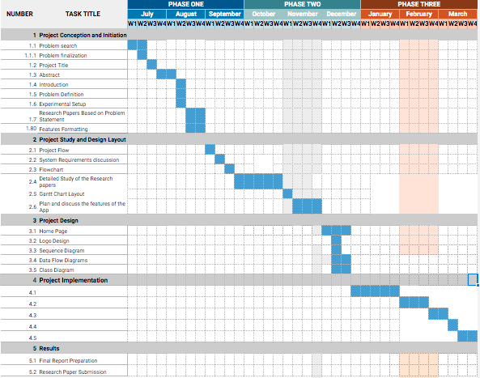

**CHAPTER 9**

**Conclusion**

In conclusion, being able to predict the status of heart health based on textual, audio & image data is a crucial step in preventing heart-related ailments. The heart disease prediction project is a complex and ambitious undertaking that involves the application of machine learning techniques to different types of data, including textual data, ECG, and audio data. The project aims to develop a comprehensive system that can accurately predict the risk of heart disease in patients based on various factors. The project has significant potential to improve the accuracy of heart disease diagnosis and treatment, leading to better health outcomes for patients.

One of the key strengths of the project is its interdisciplinary nature, involving experts from various fields such as computer science, data analysis, and healthcare. This interdisciplinary approach has led to the development of innovative solutions and techniques that can be applied to a wide range of healthcare problems beyond heart disease.

With the use of advanced technologies and machine learning algorithms, medical professionals can analyze the patterns and changes in the data to diagnose heart disease at an early stage. This can help individuals take preventive measures and improve their lifestyle to reduce the risk of heart disease. As technology continues to evolve, we can expect more accurate and efficient methods of predicting heart disease and ultimately improving the overall health of society.

**CHAPTER 10**

**Future Scope**

### With the advancement of machine learning algorithms, we can expect to see more accurate and efficient prediction models for heart disease. In the coming years, we can also expect the integration of wearable devices that can continuously monitor heart activity and detect any anomalies, providing real-time updates to healthcare professionals.

### Furthermore, predictive analytics can be used to identify specific risk factors for heart disease in different demographics, leading to targeted preventive measures. This will also enable healthcare providers to personalize treatment plans for patients, ultimately leading to better outcomes.

### The textual data model can also provide recommendations for treatment and management of heart disease. For example, the model may recommend lifestyle changes, such as diet and exercise, or medication to manage the patient's risk of heart disease. These recommendations are based on the analysis of the patient's medical history, symptoms, and other relevant information.

### The project has significant potential for future research and development. One area for further investigation is the use of deep learning techniques, such as convolutional neural networks, to analyze ECG and audio data. Deep learning techniques have shown promise in other healthcare applications, and their use in heart disease prediction could lead to further improvements in accuracy.

### Another area for future research is the integration of different types of data to develop more comprehensive prediction models. For example, integrating textual data, ECG, and audio data can provide a more complete picture of the patient's health, leading to more accurate predictions and better healthcare outcomes.

### The textual data model can use natural language processing (NLP) techniques to analyze clinical notes and other textual data to predict the risk of heart disease in patients. The UI will be divided into different sections, each representing a different aspect of the textual data model. It allow users to upload the textual data they want to analyze. The system will be designed to handle various file formats such as PDFs, Word documents, and text files.

### Users will also be able to interact with the results, clicking on different elements to get more detailed information. For example, clicking on a risk score may display the factors that contributed to that score, and clicking on a recommended treatment may provide more information about that treatment.

### The application can be designed to be responsive and adaptable, working on different devices such as desktops, tablets, and smartphones. The goal is to provide healthcare professionals with a powerful tool that is easy to use and helps them make informed decisions about patient care.

### The UI can also provide additional tools to customize the analysis, such as adjusting the sensitivity of the algorithms or selecting which parameters to analyze. The UI can also provide a way to access additional resources, such as educational materials or guidelines for treatment and management of heart disease.

### It can also be extended by building separate models for other vital organs such as the liver, brain, skin, etc. Overall, the future scope of Vital Organ Health Prediction holds great potential for improving public health and reducing the burden of heart-related ailments.

**References**

1. V. Sharma, S. Yadav, M. Gupta, “Heart Disease Prediction using Machine Learning Techniques” in the International Conference on Advances in Computing, Communication Control and Networking (ICACCCN), 2020.
2. C. Boukhatem, H. Y. Youssef, A. B. Nassif, “Heart Disease Prediction Using Machine Learning” in the Advances in Science and Engineering Technology International Conferences (ASET), 2022.
3. F. S. Alotaibi, “Implementation of Machine Learning Model to Predict Heart Failure Disease” in International Journal of Advanced Computer Science and Applications(IJACSA), 2019.
4. S. Nandhini, M. Debnath, A. Sharma, Pushkar, “Heart Disease Prediction using Machine Learning” in International Journal of Recent Engineering Research and Development (IJRERD), 2018.
5. K. Kumar, K. Chaturvedi, “An Audio Classification Approach using Feature extraction neural network classification Approach”.
6. N. Jain, M. Kamble, A. Kanojiya, C. Jage, “ Implementation of Bird Species Detection Algorithm using Deep Learning”, ITM Web Conf. 44 03042 (2022), doi: 10.1051/itmconf/20224403042
7. R. Katarya, P. Srinivas, “Predicting Heart Disease at Early Stages using Machine Learning: A Survey” in International Conference on Electronics and Sustainable Communication Systems (ICESC), 2020.
8. J. V. Jeny, P. Aishwarya, N. S. Reddy, Samreen, “A Classification Approach for Heart Disease Diagnosis using Machine Learning” in IEEE International Conference on Signal Processing, Computing and Control (ISPCC), 2021.
9. D. P. Yadav, P. Saini, P. Mittal, “Feature Optimization Based Heart Disease Prediction using machine Learning” in International Conference on Information Systems and Computer Networks (ISCON), 2021.
10. P. Motarwar, A. Duraphe, G. Suganya, M. Premalatha, “Cognitive Approach for Heart Disease Prediction using Machine Learning '' in International Conference on Emerging Trends in Information Technology and Engineering (ic-ETITE), 2020.
11. M. Saw, T. Saxena, S. Kaithwas, R. Yadav, N. Lal, “Estimation of Prediction for GettingHeart Disease Using Logistic Regression Model of Machine Learning” in International Conference on Computer Communication and Informatics (ICCCI), 2020.
12. S. Babu, Vivek EM, Famina KP, Fida K, Aswathi P, Shanid M, Hena M, “Heart Disease Diagnosis using Data Mining Technique” in International Conference on Electronics, Communication and Aerospace Technology (ICECA), 2017.
13. M. A. Kumar, Abirami N, G. Prasad, M. Mohankumar, “Stroke Disease Prediction based on ECG Signals using Deep Learning Techniques” in International Conference on Computational Intelligence and Sustainable Engineering Solution(CISES), 2022.
14. M. B. Abubaker, B. Babayigit, “Detection of Cardiovascular Diseases in ECG Images Using Machine Learning and Deep Learning Methods” in IEEE, 2022.
15. H. Purwins, B. Li, T. Virtanen, J. Schlüter, S. -Y. Chang and T. Sainath, "Deep Learning for Audio Signal Processing," in IEEE Journal of Selected Topics in Signal Processing, vol. 13, no. 2, pp. 206-219, May 2019, doi: 10.1109/JSTSP.2019.2908700.
16. Ramesh B.D.C., Vishnu R.S. (2020), “CNN and Sound Processing-Based Audio Classifier for Alarm Sound Detection” In: Dash, S., Lakshmi, C., Das, S., Panigrahi, B. (eds) Artificial Intelligence and Evolutionary Computations in Engineering Systems. Advances in Intelligent Systems and Computing, vol 1056. Springer, Singapore. https://doi.org/10.1007/978-981-15-0199-9_31
17. D. R. Megalmani, S. B. G, A. Rao M V, S. S. Jeevannavar and P. K. Ghosh, "Unsegmented Heart Sound Classification Using Hybrid CNN-LSTM Neural Networks," 2021 43rd Annual International Conference of the IEEE Engineering in Medicine & Biology Society (EMBC), Mexico, 2021, pp. 713-717, doi: 10.1109/EMBC46164.2021.9629596
18. Chen W. Sun Q. Chen, X. Xie, G. Wu, H.; Xu, C. “Deep Learning Methods for Heart Sounds Classification: A Systematic Review” Entropy 2021, 23, 667. https:// doi.org/10.3390/e23060667
19. Soeta, Y.; Bito, Y. Detection of features of prosthetic cardiac valve sound by spectrogram analysis. Appl. Acoust. 2015, 89, 28–33.
20. Chakir, F.; Jilbab, A.; Nacir, C.; Hammouch, A. Phonocardiogram signals processing approach for PASCAL Classifying Heart Sounds Challenge. Signal Image Video Process. 2018, 12, 1149–1155. [CrossRef]
21. Potes, C.; Parvaneh, S.; Rahman, A.; Conroy, B. Ensemble of feature based and deep learning-based classifiers for detection of abnormal heart sounds. Proc. Comput. Cardiol. Conf. 2016, 621–624. [CrossRef]
22. Thalmayer, A.; Zeising, S.; Fischer, G.; Kirchner, J. “A Robust and Real-Time Capable Envelope-Based Algorithm for Heart Sound Classification: Validation under Different Physiological Conditions”. Sensors 2020, 20, 972
23. N. Peng, A. Chen, G. Zhou, W. Chen, W. Zhang, J Liu, F. Ding, “Environment Sound Classification Based on Visual Multi-Feature Fusion and GRU-AWS” in IEEE Access, 2020
24. K. Dissanayake, Md Gapar Md Johar, “Comparative Study on Heart Disease Prediction Using Feature Selection Techniques on Classification Algorithms,” in Applied Computational Intelligence and Soft Computing Volume 2021.
25. A. J. Prakash, Samit Ari, “AAMI Standard Cardiac Arrhythmia Detection with Random Forest Using Mixed Features,” in IEEE, 2019.

**Publications**

**Paper 1: Random Forest vs Logistic Regression for Heart disease prediction**

Conferences:

[1] 9th Somaiya International Conference on Technology and Information Management [(SICTIM ’23)](https://simsr.somaiya.edu/en/conference/SICTIM)

Status: Submitted

**Paper 2: Heartbeat Prediction using Mel Spectrogram and MFCC value**

Conferences:

[1] 2023 3rd Asian Conference on Innovation in Technology

[2] International Conference on Power Engineering and Intelligent System

[3] 2023 IEEE IAS Global Conference on Emerging Technologies (GlobConET)

Status: Submitted